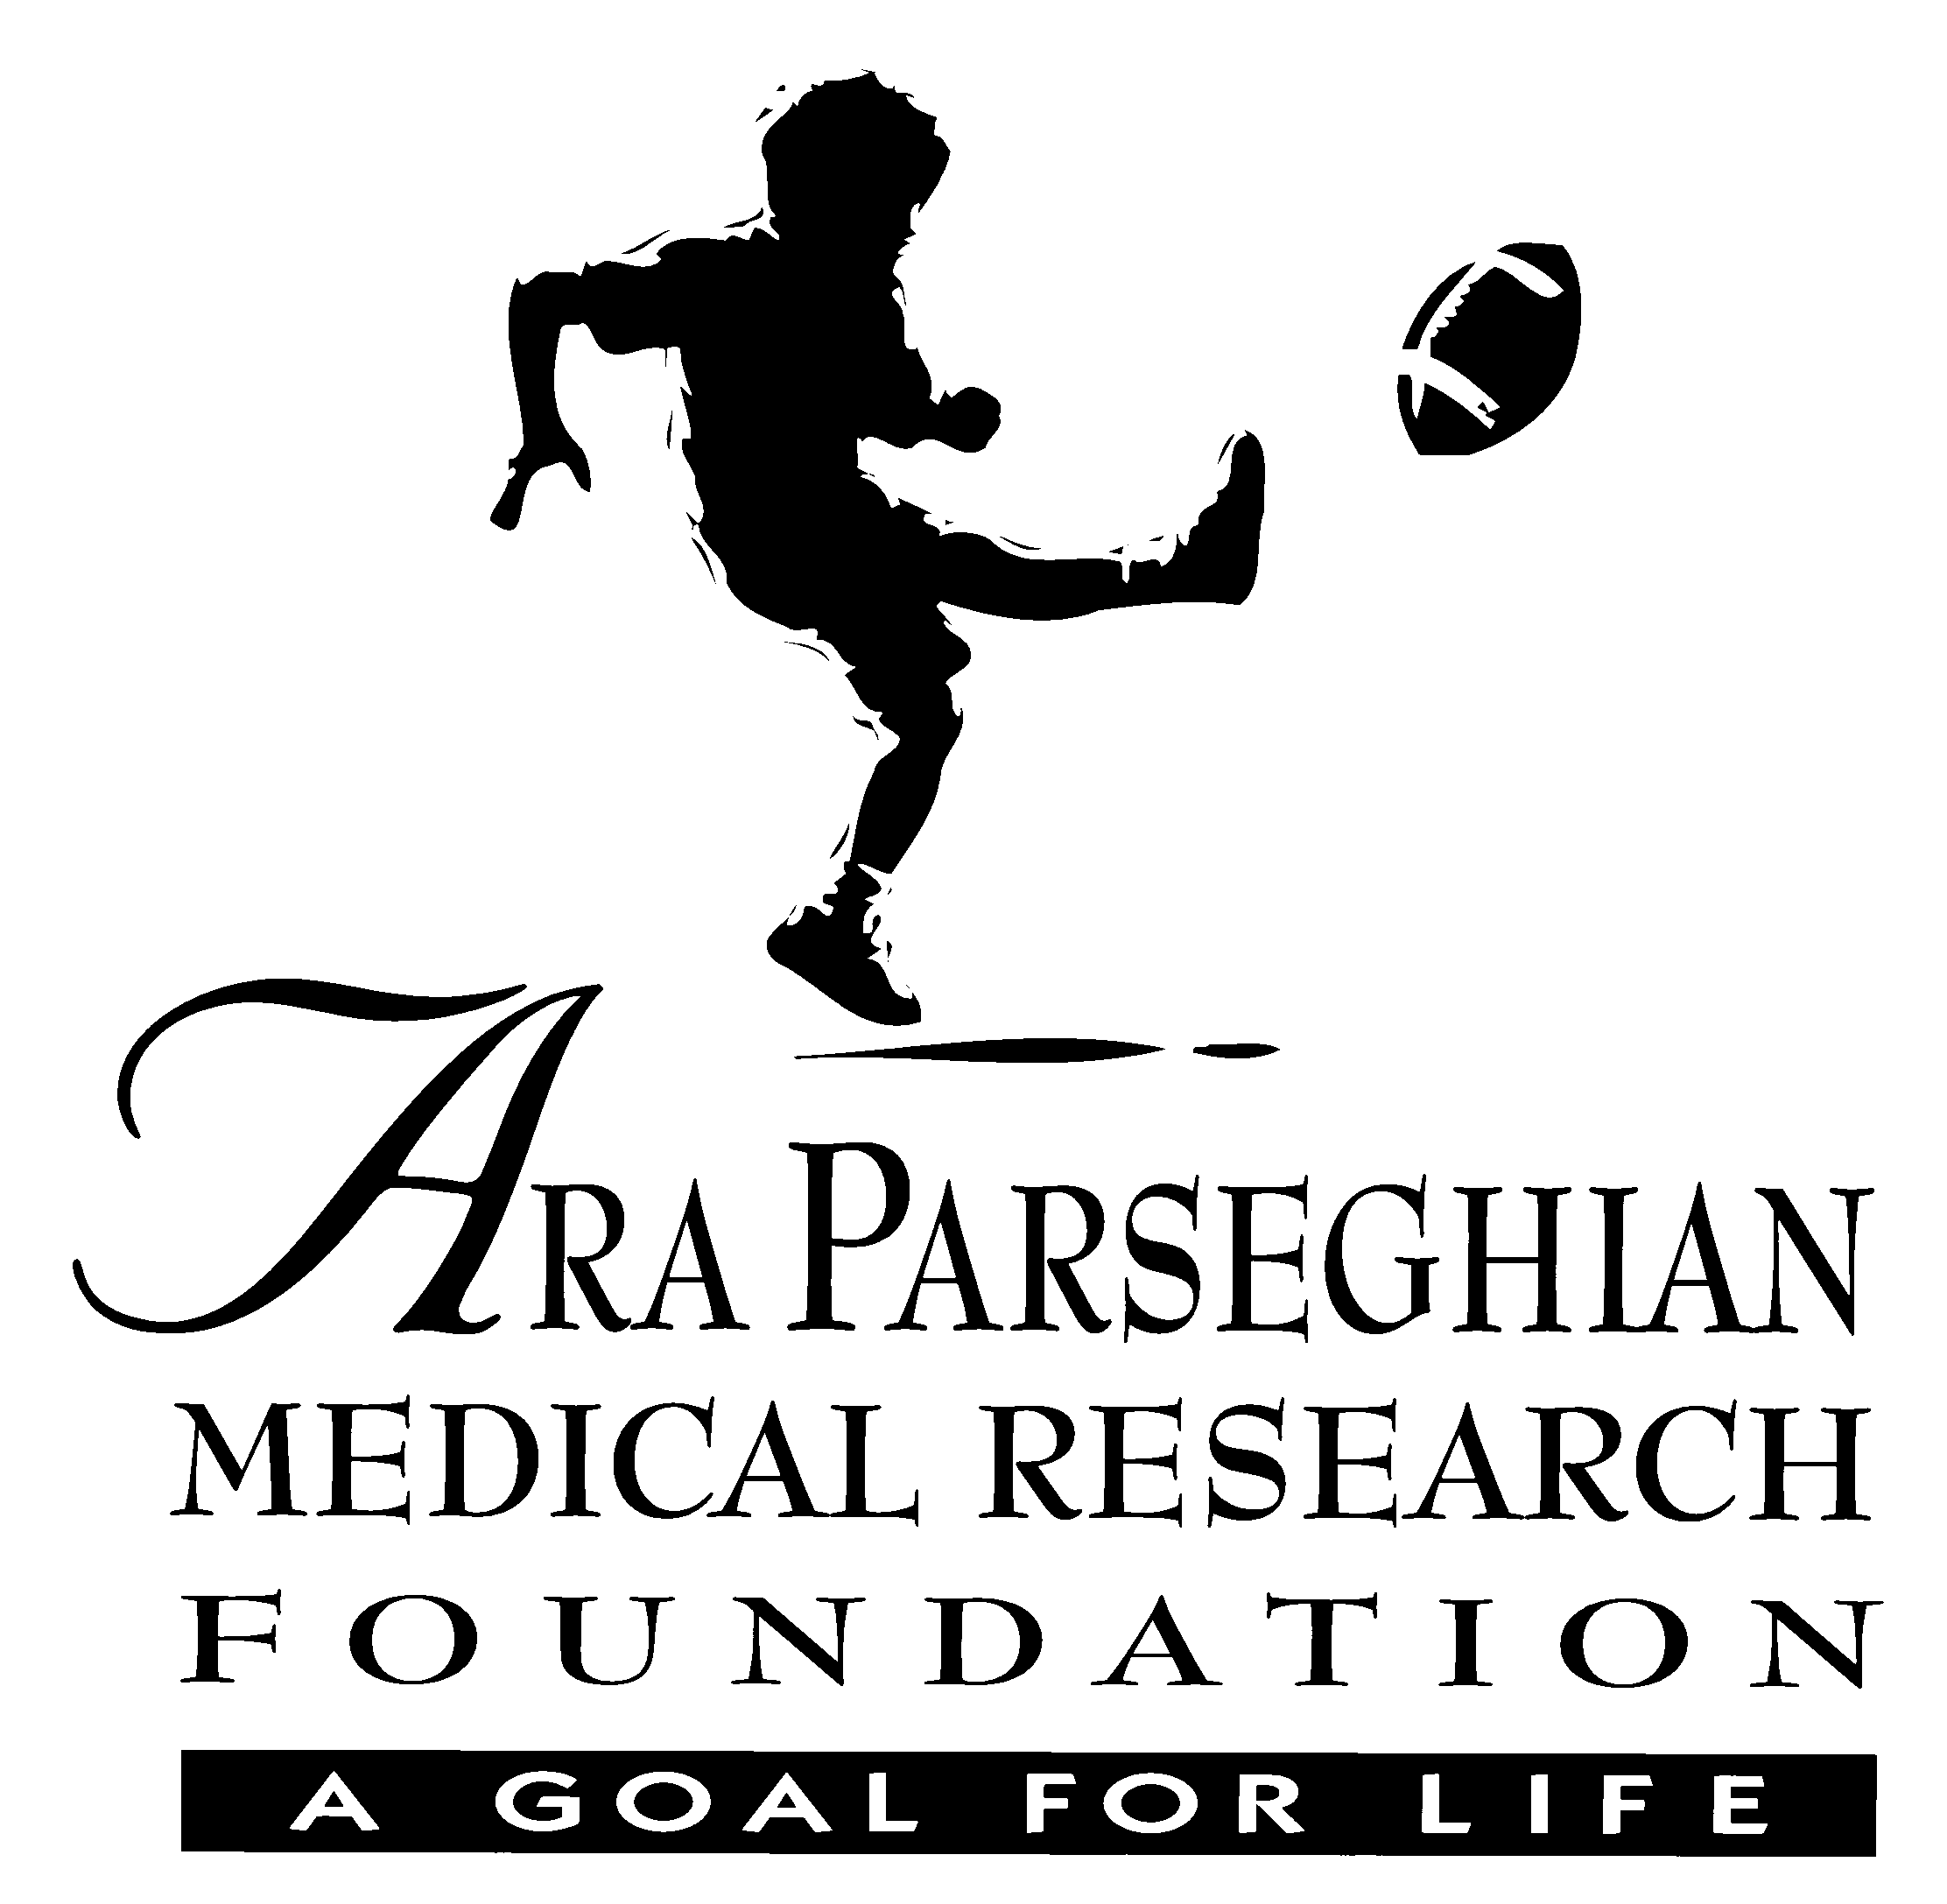

July 20, 2011

Mr. and Mrs. Trent Smith
2207 Wake Robin Dr
Lafayette, IN 47906

Dear Trent, Julie and Volunteers for the 4rd Annual Smith Family “BReaK Thru Fund Golf Outing”:

On behalf of the Ara Parseghian Medical Research Foundation, and all families afflicted with Niemann-Pick Type C (NP-C) disease, I want to thank you sincerely for offering to host a fundraising event on Saturday, August 6, 2011 in Lafayette, IN to benefit the work of the Parseghian Foundation.

Funding medical research is our hope in finding a treatment and cure for your children, Riley and Keaton, as well as all the other children and young adults living with this terrible disease.

You have the full support of the Parseghian Foundation in your efforts with this event. Many Niemann-Pick families across the country host fundraising events of various kinds to raise funds for research. After completing two successful events held in Lafayette and now in planning for the third event, I am sure the Lafayette community will rally even more behind this important cause.

It is our hope that many individuals, businesses and organizations in the Lafayette area will come forward once again to help make the event a success by donating or deeply discounting many of the services needed to host such an event.

Because all proceeds from your event will be given to the Ara Parseghian Medical Research Foundation to help cover the cost of the $2 million dollars we have committed to NP-C research each year, you can provide donors with our Tax ID # which is: 86-0775966.

We wish you the very best in planning, promoting and hosting this event in honor of Riley, Keaton and Braden, and all children with Niemann-Pick Type C disease.
Together…we will conquer this devastating disease.

Sincerely,

Cindy Parseghian
President

3530 E Campo Abierto, Ste 105 Tucson, AZ 85718
520.577.5106 (ph) 520.577.5212 (Fax)

